Household Water-Usage & Billing Monitor

1c) Methods:

Write a Java program to calculate the total water consumption of a household using a method.

Create the following method:

calculateTotal(int morningUsage, int eveningUsage)

The method should return the total water consumption. Read the morning and evening water usage from the user, call the method, and display the total consumption.

CODE :

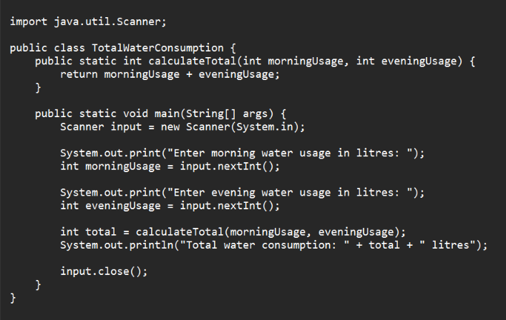

OUTPUT :

